Elmwood Giants Baseball Club Inc.
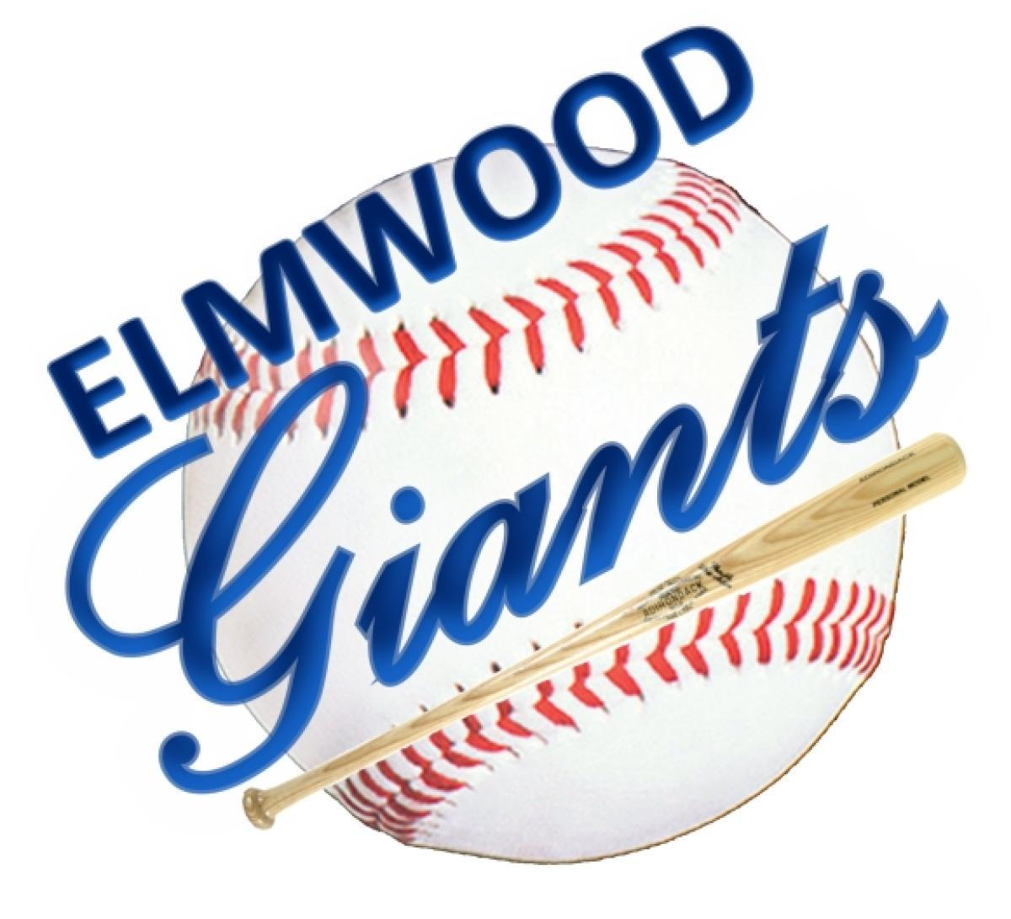
More than 100 Years of baseball in Our Community
Results of the 2018 Elmwoods Giant Cash Calendar Draw

November 1 - for $500, Ticket 1090, winner Amber Marion
November 2 - for $75, Ticket 1245, winner Tim Muron
November 3 - for $100, Ticket 1520, winner Ethel Campbell
November 4 - for $100, Ticket 0255, winner Janet Sanders
November 5 - for $25, Ticket 2549, winner Frank Sikdra
November 6 - for $25, Ticket 1250, winner Kurt Terrick
November 7 - for $25, Ticket 1889, winner Shauna Stamler
November 8 - for $25, Ticket 1704, winner Brian McIntyre
November 9 - for $75, Ticket 2569, winner David Jarvis
November 10 - for $100, Ticket 2899, winner Diane Minion
November 11 - for $100, Ticket 0266, winner Trish Wark
November 12 - for $25, Ticket 1277, winner Rob Ferrand
November 13 - for $25, Ticket 2162, winner Jack Callum
November 14 - for $25, Ticket 2835, winner Arlene & Steve Ritchie
November 15 - for $25, Ticket 0107, winner Tony Pimentel
November 16 - for $75, Ticket 0521, winner Megan Brisco
November 17 - for $100, Ticket 0923, winner Scott Kulyk
November 18 - for $100, Ticket 2617, winner Thom Wolstencroft
November 19 - for $25, Ticket 0951, winner Al Dearlorie
November 20 - for $25, Ticket 1572, winner Dave Babiuk
November 21 - for $25, Ticket 1995, winner Gerald Palidwor
November 22 - for $25, Ticket 1843, winner Bill Stoughton
November 23 - for $75, Ticket 1673, winner Hazel Lemieux
November 24 - for $100, Ticket 0221, winner Duane Langbis
November 25 - for $100, Ticket 0041, winner Joe Arbuckle
November 26 - for $25, Ticket 2924, winner Danny Schink
November 27 - for $25, Ticket 0046, winner Dave Sayer
November 28 - for $25, Ticket 1228, winner Phil Siemens
November 29 - for $25, Ticket 2248, winner Darren Anderson
November 30 - for $1000, Ticket 0248, winner Sherri Bastien

