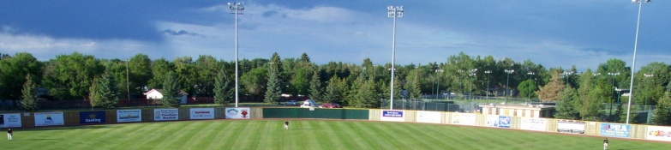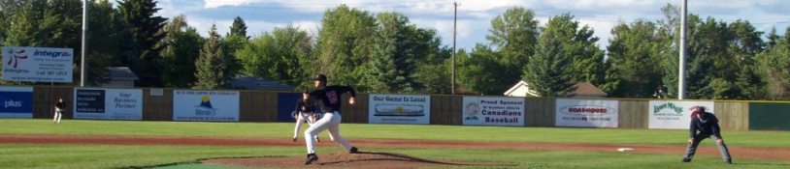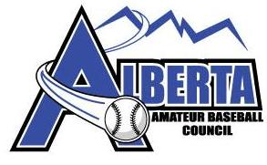



.**Other Programs**

* Development Programs

1. Spring Training
2. Winter Development Camps

* Scholarship Programs
* Spit Tobacco Awareness
* Coaching Mentorship

1. Guest Coaching
2. Online Resource

**Spring Training**

* Easter Long weekend in Lethbridge
* Developmental Program for 14,15 and 16 year olds
* Athletes invited to attend Camp to ensure a good start to the season

**Winter Camps**

* To provide athletes with Winter Skill Development
* Offered to Team Alberta Athletes that do not participate in full year baseball training
* Will be offered to 14, 15 year olds

**Scholarship Program**

* Provide individual Scholarships to attend an Alberta Collegiate Baseball Programs ($1000 per scholarship)
* Information to be posted on www.albertabaseball.org

**Spit Tobacco Awareness**

* Create awareness around spit tobacco and the dangers
* Information to be accessible through www.albertabaseball.org

**AABC Coach Mentorship**

**Guest Coaching/Online Resource**

* Please see www.albertabaseball.org for Guest Coaching Opportunities and coming soon the online resource.

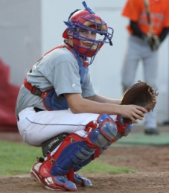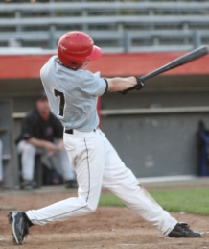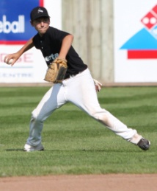

**Coaching and Hosting Opportunities**

* If you are a coach and would like to apply or be a part of the AABC Coaching Staff please visit our website for coaching opportunities.
* If your community or association would like to apply to host an AABC event please visit our website for all hosting opportunities.

**THANK YOU AND WELCOME**

* The AABC membership would like to Thank Kevin Kvame for his 12 year commitment to the AABC. Under his tenure Alberta’s High Performance programs have excelled on the national stage. Through the AABC, Grassroots and Development Baseball has been one of the highest recipients of Provincial Government funding.
* We would like to welcome new president Ron Van Keulen, we hope to continue and enhance Alberta baseball on the national stage in terms of competition and development**.**

**Information Guide**

**2011**

**AABC Programming**

**Contact Us**

**AABC Office 403 320 2025 ext 26**

**www.albertabaseball.org**

Aaron Lavorato a.lavorato@albertabaseball.org

High Performance Coordinator

Brandon Magierowski b.magierowski@albertabaseball.org

Communication Manager