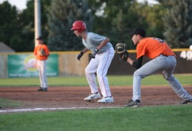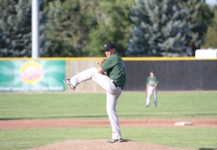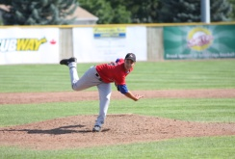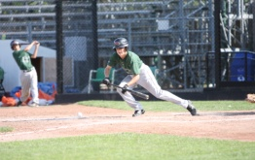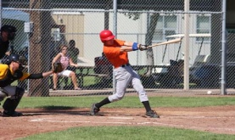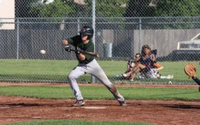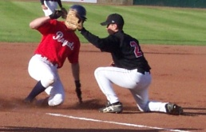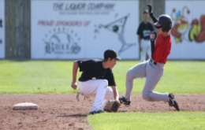

**TEAM ALBERTA 2011**

* **Western Canada Games – 15 and Under**
* **Prospect Teams – 15 Year Old Team and 16 Year old Team**
* **Canada Cup – 17 and Under (Baseball Alberta)**

**Western Canada Summer Games Team Alberta**

* Western Canada Summer Games, Kamloops BC August 5th – 9th 2011
* Ages 15 and Under
* Selection Process:

1. Talent ID
2. Evaluation Camp – Competition

* YEAR 2 of Quad Plan leading up to 2013 CANADA SUMMER GAMES, Quebec

**Prospect Series Teams**

* 16 year old and 15 year old teams to compete against Manitoba and Saskatchewan in September 2011, in Swift Current SK
* 15 year old Team selected from Alberta Summer Games/Alberta Zone Championships
* 16 year old Team selected from 16 year old Alberta Tournament

**Canada Cup 16/17 Year Old – Baseball Alberta**

* The Canada Cup is a Baseball Canada Program therefore it is administered by Baseball Alberta, however all athletes in the province are eligible.
* Selection Process begins with Talent ID.

**PROVINCIAL TOURNAMENTS**

* Alberta Summer Games/ Alberta Zone Championships
* 16 Year Old Alberta Tournament
* 13/14 Year Old Extravaganza

**Alberta Summer Games / Alberta Zone Championships**

* 2011 is an Alberta Zone Championships Year. This tournament is held in the off year of the Alberta Summer Games. August, Location TBA. In 2012 the Alberta Summer Games will be held in Lethbridge.
* Zone Teams represent each athletic zone in the province (8 zones – 8 teams)
* Zone Teams to be selected by zone coaches beginning at Talent ID.
* 15 year old Prospect Team to be selected from this tournament
* To apply to be a zone coach please visit our website.

**16 Year Old Alberta Tournament**

* Alberta Club Tournament in August, Location TBA
* Club teams compete in a province wide tournament
* 16 year old Prospect Team to be selected from this tournament

**13/14 Year Old Extravaganza**

* 13/14 Year Old Extravaganza Tournament, September long weekend, Location TBA
* Province wide club team tournament
* Introduces athletes to provincial competition
* Identification for athletes for future provincial teams.

. **What is the AABC?**

* The AABC Membership is made up of 5 stakeholders for baseball in the province

1. Little League Alberta
2. Baseball Alberta
3. American Legion Baseball
4. Babe Ruth Baseball
5. Collegiate Baseball (U of C and PBA)

* The AABC is responsible for the relationship between grassroots and development baseball and the Alberta Sport Recreation Parks and Wildlife Foundation.
* This relationship results in funding, for the member organizations

**TALENT IDENTIFICATION CAMPS**

* To be eligible for AABC programming you must attend at least one Talent Identification Camp.
* AABC Talent ID is for 13-15 year olds and runs in partnership with Baseball Alberta’s Talent Identification for 16 and 17 year olds.
* There is no cost to attend and the schedule is posted on www.albertabaseball.org

