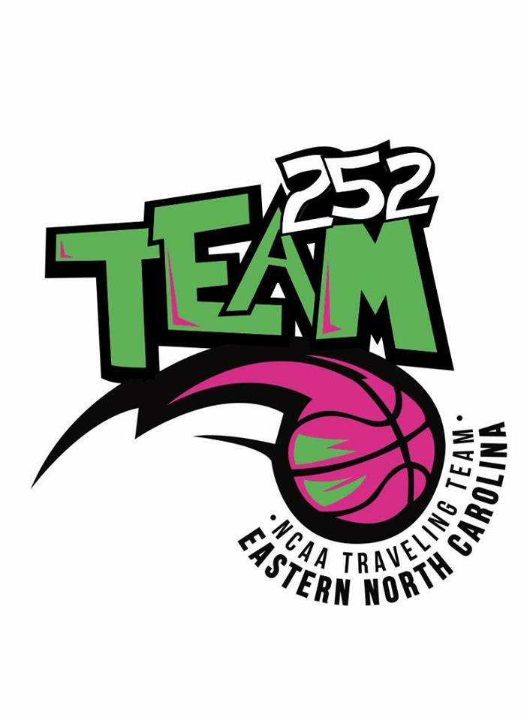
OUR MISSION
OUR MISSION HERE WITH TEAM 252 is to teach, develop, organize, manage and offer youth players the opportunity to learn the fundamental skills of basketball while instilling life-lessons and values such as character, team work, discipline, respect and sportsmanship. WE PROVIDE HEALTH AWARENESS THROUGH AMATUER SPORTS. WE GIVE ALL YOUTH THE OPPORTUNITY TO COMPETE IN COMPETITIVE SPORTS ALONG THE EAST COAST AND MID WEST. OUR MISSION IS TO HELP KIDS FIGHT OBESITY. WE ALSO GIVE STUDENT ATHLETES THE OPPORTUNITY TO RECEIVE ATHLETIC SCHOLARSHIPS BY PLAYING BASKETBALL ON THE NCAA “LIVE” CIRCUIT.

