Softball Sunday
Skills Clinic
Date: Sunday, July 23rd
Location: Mifflinburg Area High School Softball Field
Cost: $75.00 per player
Who:
- 1st session- open to non-high school players
- 2nd session- open to high school players

Clinic Timeline
- Session #1 (all non high school players)
  - Registration: 8:30am-9am
  - Time: 9am-12:30pm
- Session #2 (all high school players)
  - Registration: 12:30pm-1pm
  - Time: 1pm-5pm

Instructed by Softball Collegiate Athletes

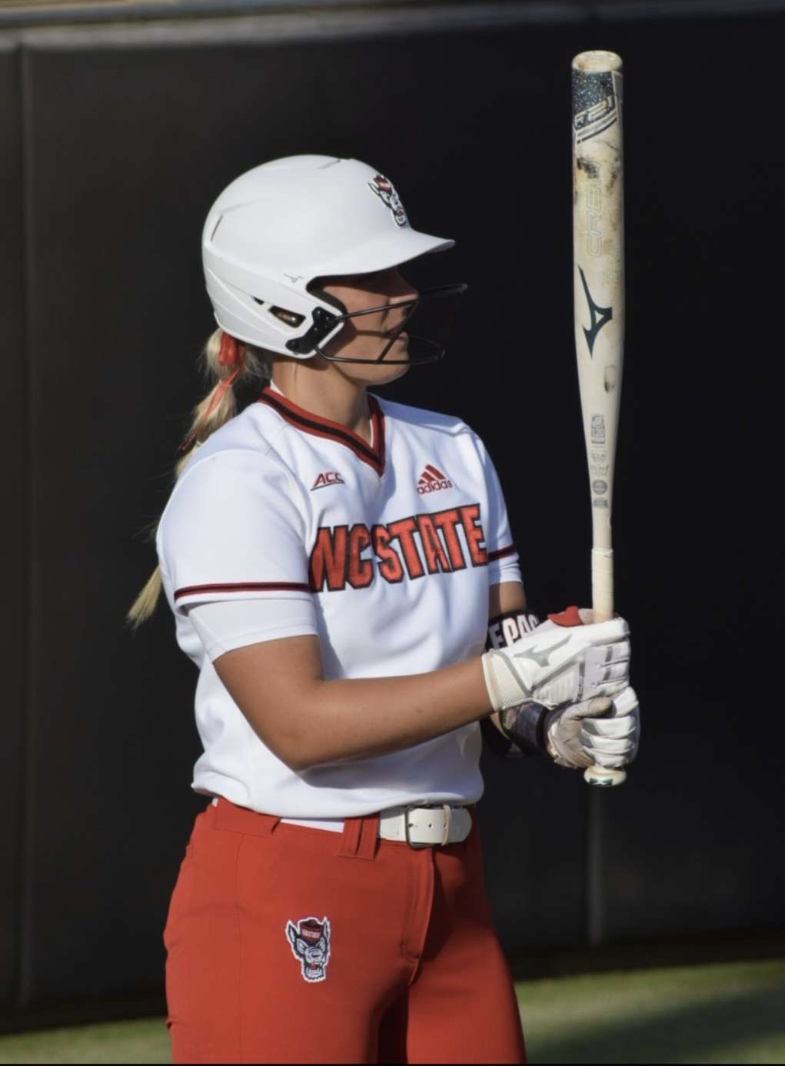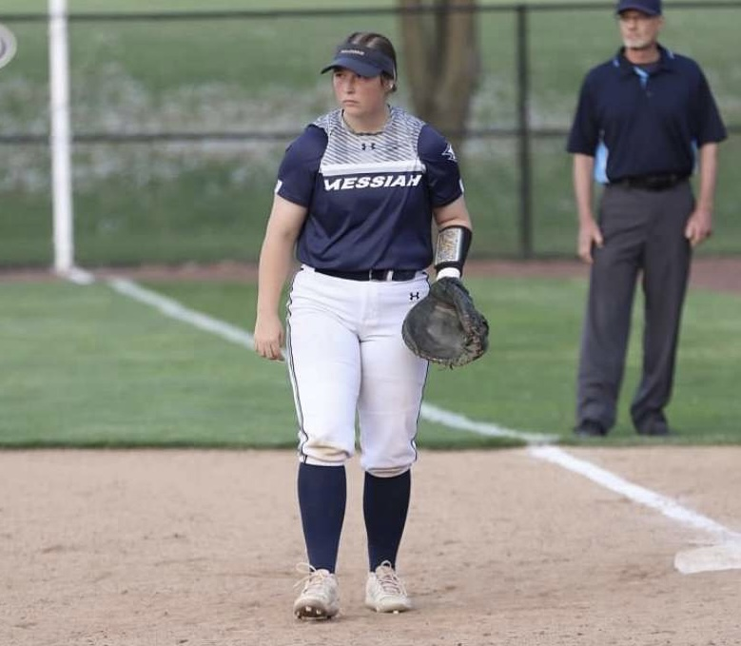

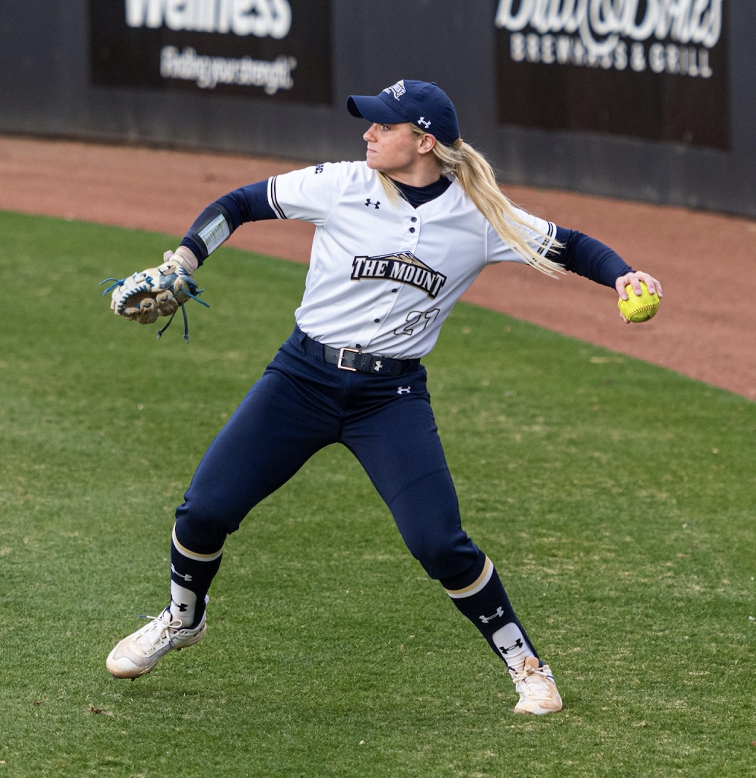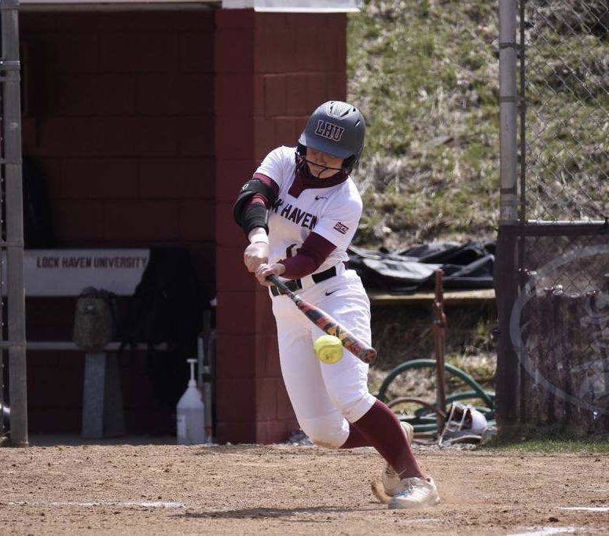

Libby Whittaker- Played at NC State

Jaden Keister- Plays at Messiah University

Layout of Sessions
- Defensive portion: Infield and outfield mechanics and drills.
- Offensive portion: Breaking down the swing and working on proper mechanics of hitting.
- The Mental Game portion: Breaking down the mental side of the game of softball and how to develop the best mindset as a softball player.

Vanessa Martin-Played at Mount St. Mary’s University
Delaney Good- Plays at Lock Haven University

- Registration will take place a half an hour before the start of each session.
- Please bring appropriate equipment (bats, helmets, gloves, mouth guard etc.) P.S. helmets are available as needed.

HOW TO REGISTER

- Fill out Registration Form and send to Tone1632@yahoo.com.
- Cash or Check accepted at registration on Softball Sunday.
  - Checks made payable to Ron Hernandez
    - Address: P.O. Box 129 Laurelton Pa 17835.
- REGISTRATION DUE BY JULY 15th
- For any clarification on registration please contact Jaden Keister at 570-217-4407.

Feel free to contact Vanessa Martin for any additional questions you may have about the clinic at 570-765-1640
Registration Form

Name: _________________________________
Circle Session choice:
Session #1: 9am-12:30pm Non-High School age
Session #2: 1pm-5pm Player that will be entering High School in 2023 and older.
(If you are a younger player that would like to be considered for session 2 please contact Jaden 570-217-4407)
Circle Primary defensive position: Infield or Outfield
Parent/Guardian Name: __________________________________
Address: _________________________________________
High School: ____________________________ Age: ___________
Phone: ___________________
Email (for clinic confirmation and additional information): ___________________________________
Circle Form of Payment: CHECK CASH

Clinic Payment and Contact Information
Email: Tone1632@yahoo.com
Phone: Jaden Keister - 570-217-4407
Mail: Pay to- Ron Hernandez
Address- P.O. Box 129 Laurelton Pa 17835

