2018 Player Registration Size Chart Guide

Jersey Size Guide:
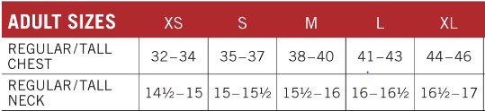
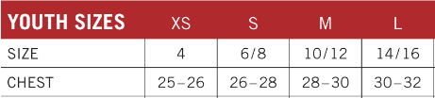
Pant Size Guide:
Adult Inseam: S(31”), M(32”) or L(33”)
Adult Waist: S(26-28), M(30-32) or L(34-36)
Youth Inseam: S(24”), M(25-1/2”) or L(27”)
Youth Waist: S(20-22), M(24-26) or L(28-30)
Hat Size Guide:
Youth: 6-1/2 to 6-7/8
Adult Small/Medium: 6-7/8 to 7-1/4
Adult Medium/Large: 7-1/4 to 7-5/8

