Black Tornado Baseball Pitching Mechanics: Pictures
---------------------------------------------------------------------------------------------------------------------

A. Goals for Today: Plan of Attack

1. Health: Increase Durability and Reduce Health Risks or Injury

2. Command in the Strike Zone

3. Command out of the Strike Zone

4. Increase Velocity

5. Increase Command of Fastball

6. Increase Command of Secondary Pitches

7. Increase our Functional Strength

8. Increase our Movement Patterns

Page # 1

Pitching Mechanics Cont.

A. The Big 3 Components: Balance, Timing and Power

1. Balance

With balance I am talking about dynamic balance, or balance while moving. We’re also talking about your glove side matching your throwing side, your upper half matching your lower half, everything linked up and in sync. So if you want a powerful pitching delivery that you can repeat consistently, you have to get good at controlling your body while moving.

2. Timing

Timing is all about linking up the movements in your delivery to promote efficient transfer of energy up your kinetic chain as you pitch. Any time things get out of sync, or there’s a disruption to this chain of movements, control and velocity will suffer. Pitching drills that focus on “getting the arm up” create timing issues that can reduce velocity and increase the risk of injury. Our program is designed to help you create power with your lower half and transfer that power up your body as you pitch - everything in sync, arms and legs working together.

3. Power

Power in your pitching delivery starts with your legs and your lower half. Studies have shown that the biggest differences between high velocity pitchers and low velocity pitchers occur in the early phases of the pitching delivery (the load and stride phase). Power pitchers are able to use momentum to create power in the stride phase, and then convert that to powerful hip and trunk rotation.

Note: We want Explosive Movement with Powerful Weight Shift
from back to front.
Page # 2

Pitching Mechanics Cont.

B. Velocity and the 4 Power Pitching Components

1. Linear Movement

Linear momentum is your body moving in a line towards the target. Creating momentum by getting your center of gravity moving towards home plate early in your motion; which is critical for generating power and developing good timing in our delivery.

2. Loading the Hips

Leading with the hips is not the right term. Why? We get pitchers sticking out their front hip and tilt backwards and we are not creating momentum. Instead we want to shift our weight, getting our center mass moving towards home plate in our leg lift.

3. Hip to Shoulder Separation

This refers to the concept of opening the hips into foot plant while delaying shoulder rotation. So at foot plant your belt buckle should be facing more towards home plate while your chest and shoulders are still closed. This creates torque and elastic energy; which converts linear momentum in the stride with powerful rotational forces.

4. Stabilizing the Front Side

In order to convert linear momentum and torque into maximum rotational power, we have to brace up well and stabilize our front side. Your landing foot, front knee, and glove arm all act together to stabilize and transfer power from you lower half to your upper half and out to your arm as you pitch.
Page # 3

Pitching Mechanics Cont. Windup

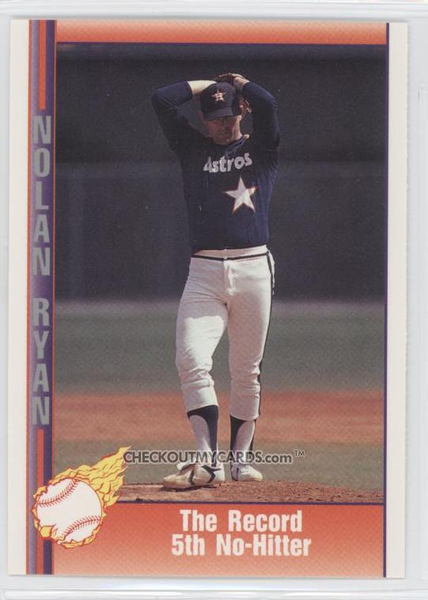

Page #4

Pitching Mechanics Windup

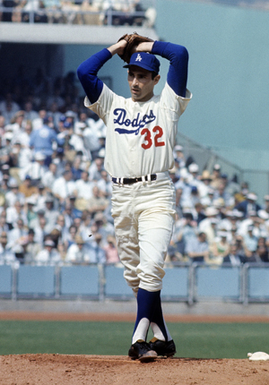

Page #5

Pitching Mechanics Windup

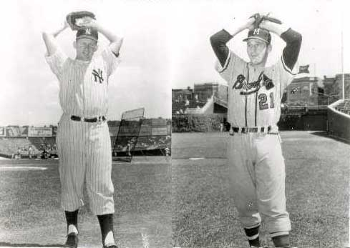

Page # 6

Pitching Mechanics Cont. Stretch

Page # 7

Pitching Mechanics Stretch

Page # 8

Pitching Mechanics Stretch: High Balance
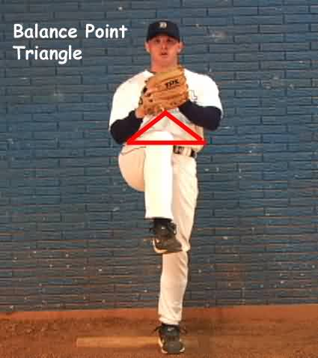

Page # 9

Pitching Mechanics Weight Shift

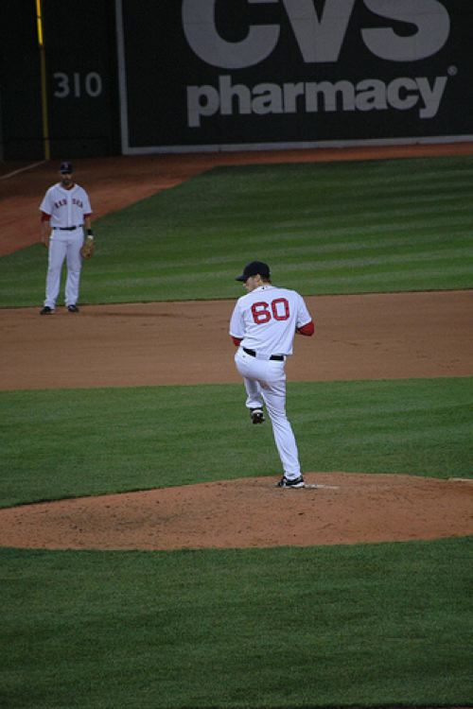

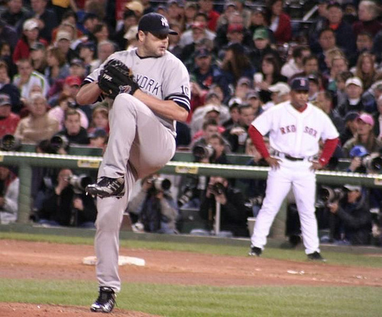

Page # 10

Pitching Mechanics Weight Shift

Good Early Momentum

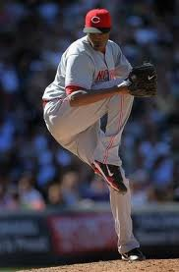

* Hands together as pitcher moves out with good balance and posture
* Center mass moving out and down together in sync with legs and arms
* Hips drop or sink for power s pitcher moves out
* Power angle set in back leg. Back knee and shin angle.
- Step Behind Mound Page # 11
- Step Behinds and Double Leg lift

Pitching Mechanics Weight Shift

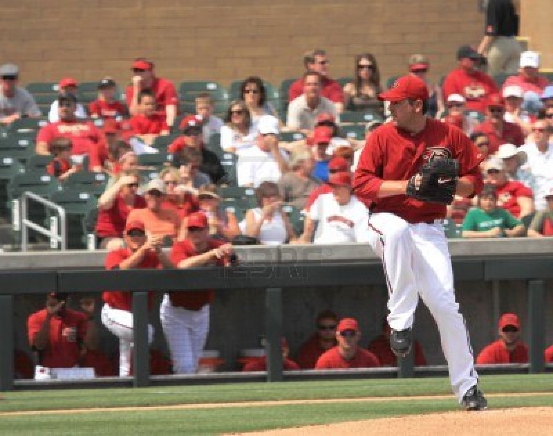

Page # 12

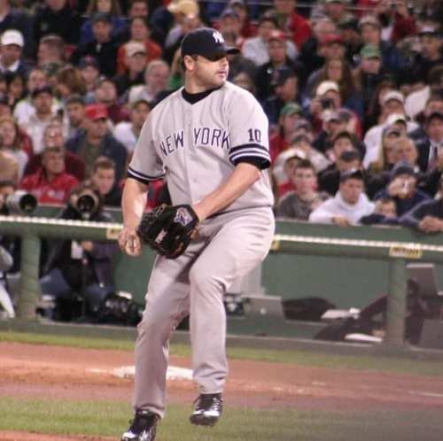
Pitching Mechanics Hand Break and Leg Drive

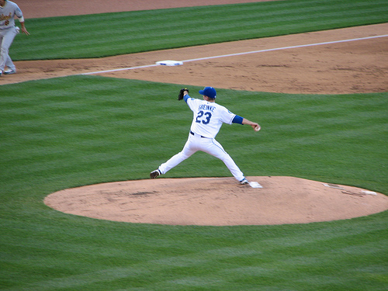

Page # 13

Pitching Mechanics Hand Break and Leg Drive

Page #14

Pitching Mechanics Drive: Stride and Direction

Page # 15

Pitching Mechanics Drive: Stride and Direction

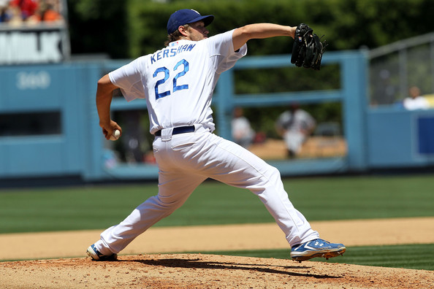

Page # 16

Pitching Mechanics Drive: Stride and Direction

Page # 17

Pitching Mechanics Drive: Stride and Direction
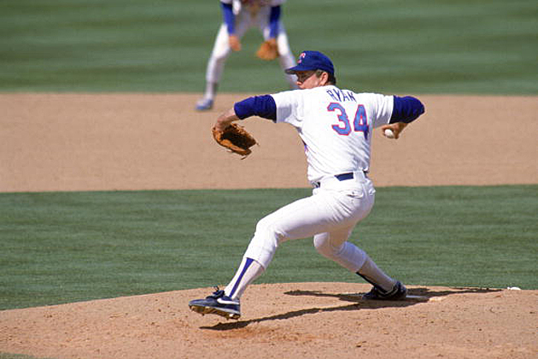

Page # 18

Pitching Mechanics High Power: Landing

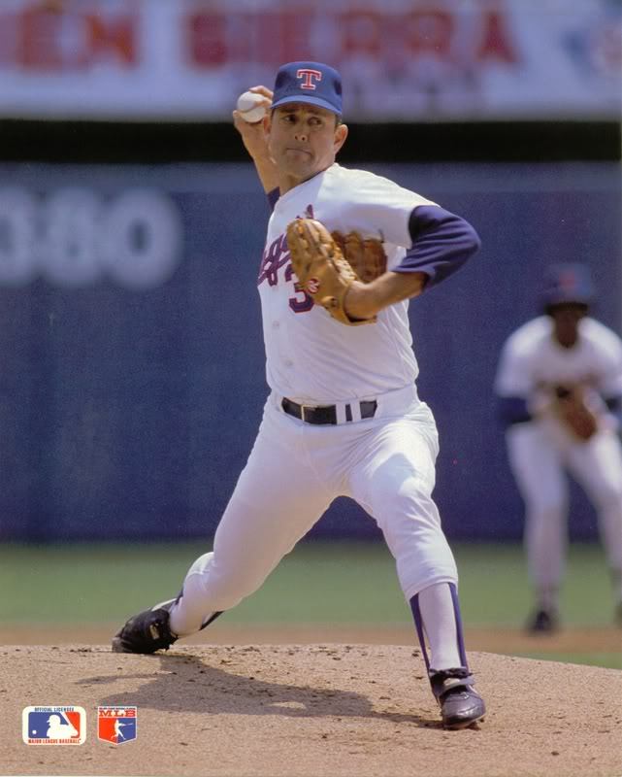

Page # 19

Pitching Mechanics High Power: Landing

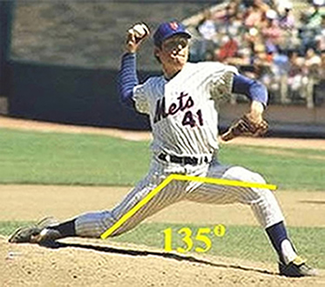

Page # 20

Pitching Mechanics Maximum Torque Position: Front Hip to Shoulder Separation

* Torque and Elastic Energy *
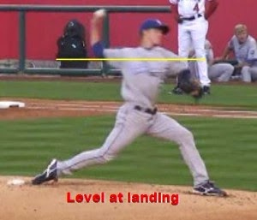

* Legs and arms in sync.
* Opening the hips into foot plant while delaying shoulder rotation.

- Creates torque and elastic energy
- This converts linear momentum in the stride to powerful rotational forces.

Page # 21

Pitching Mechanics Maximum Torque Position: Front Hip to Shoulder Separation

* Torque and Elastic Energy *

* Legs and arms in sync.
* Opening the hips into foot plant while delaying shoulder rotation.

- Creates torque and elastic energy
- This converts linear momentum in the stride to powerful rotational forces.

Page # 22

Pitching Mechanics Maximum Torque Position: Front Hip to Shoulder Separation

Rotation: Glove position and trunk. Throwing arm and hand are just like connection ball.
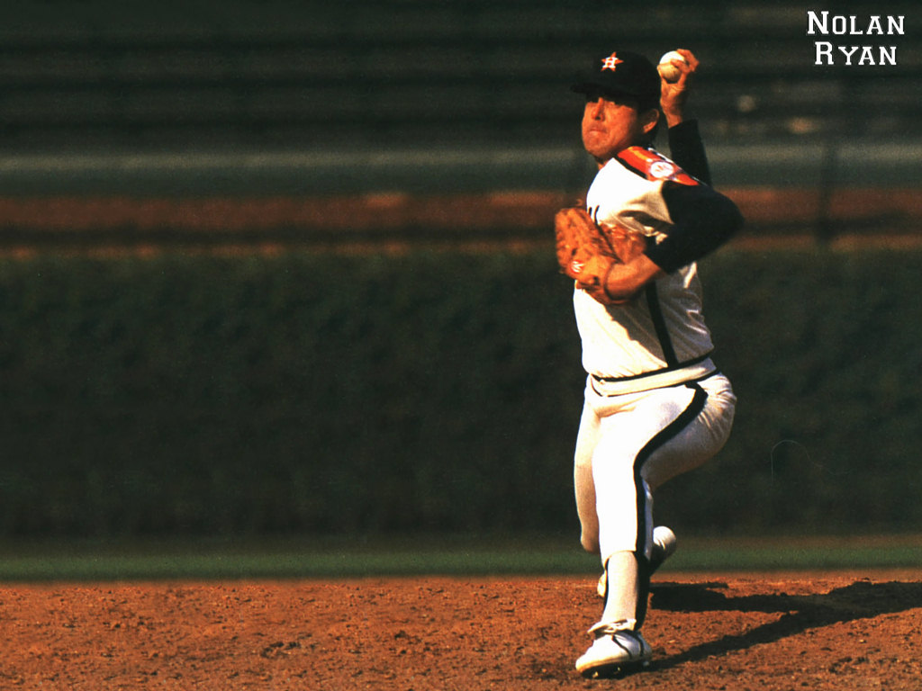

Page # 23

Pitching Mechanics External Rotation: Stack and Track

Page # 24

Pitching Mechanics External Rotation

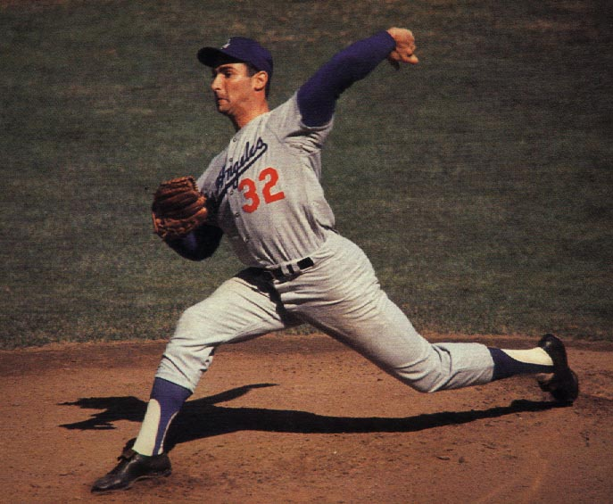

Page # 25

Pitching Mechanics Getting to Ball Release

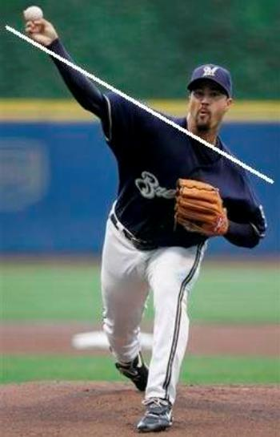

Page #26

Pitching Mechanics Ball Release

Page #27
Pitching Mechanics Ball Release: Extension out Front

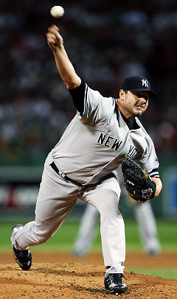

Page # 28

Pitching Mechanics Ball Release: Extension out Front

Correct: Front Knee Extends into Ball Release

* In order to convert linear momentum and torque into maximum rotational power, we
have to brace up well and stabilize our front side.

* Your landing foot, front knee, and glove arm all act together to stabilize and transfer
power from you lower half to your upper half and out to your arm as you pitch.

Page # 29

Pitching Mechanics Finish and Follow Through

Page # 30

Pitching Mechanics Finish and Follow Through
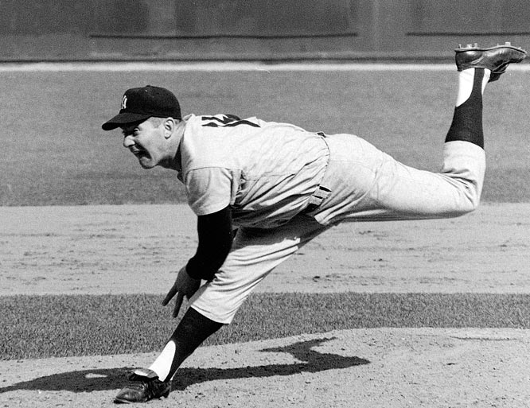

Page # 31

Pitching Mechanics Finish and Follow Through
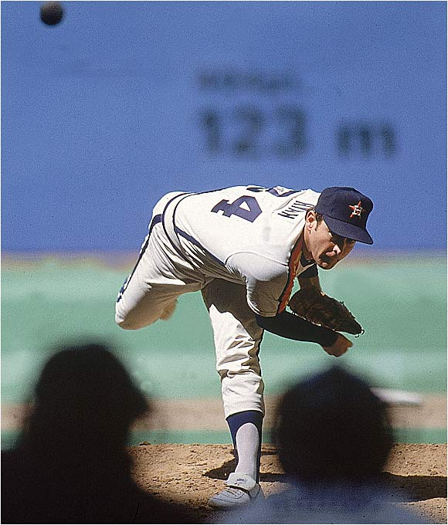

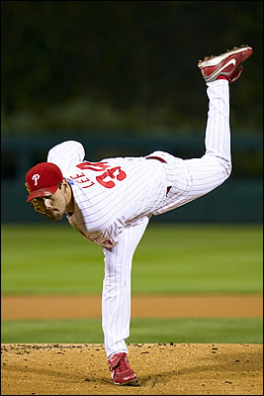

Page # 32

