B. PHASE #2 ….. Coil or Load

1. Coil into your load. K-Posture

2. Weight transfers back to go forward.

a. Weight shifts to back leg
b. Front knee will flex, as the front heel will lift off the ground.

3. The hands go back with the hips and point the knob of the bat
to the catcher, but do not wrap the bat.

a. This loads the bottom hand and will cock the wrist and
it will load the hands just outside the back shoulder. (Radial Deviation)

b. Rock the Cradle.
c. Rhythmic Action.

4. The head will follow the hands back; which helps transfer
weight back.

a. Hips load belly button from the middle of the plate to the tip
of the plate.

b. Shoulders remain on line with the pitcher while loading of
the hips.

5. Loose and relaxed with no tension in the back and shoulders.

6. Eyes stay on a focal point or release point of the pitcher.

Page # 5

B. PHASE #2 ….. The Load or Coil

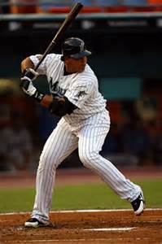

Page # 6
PHASE #2 ….. The Load or Coil

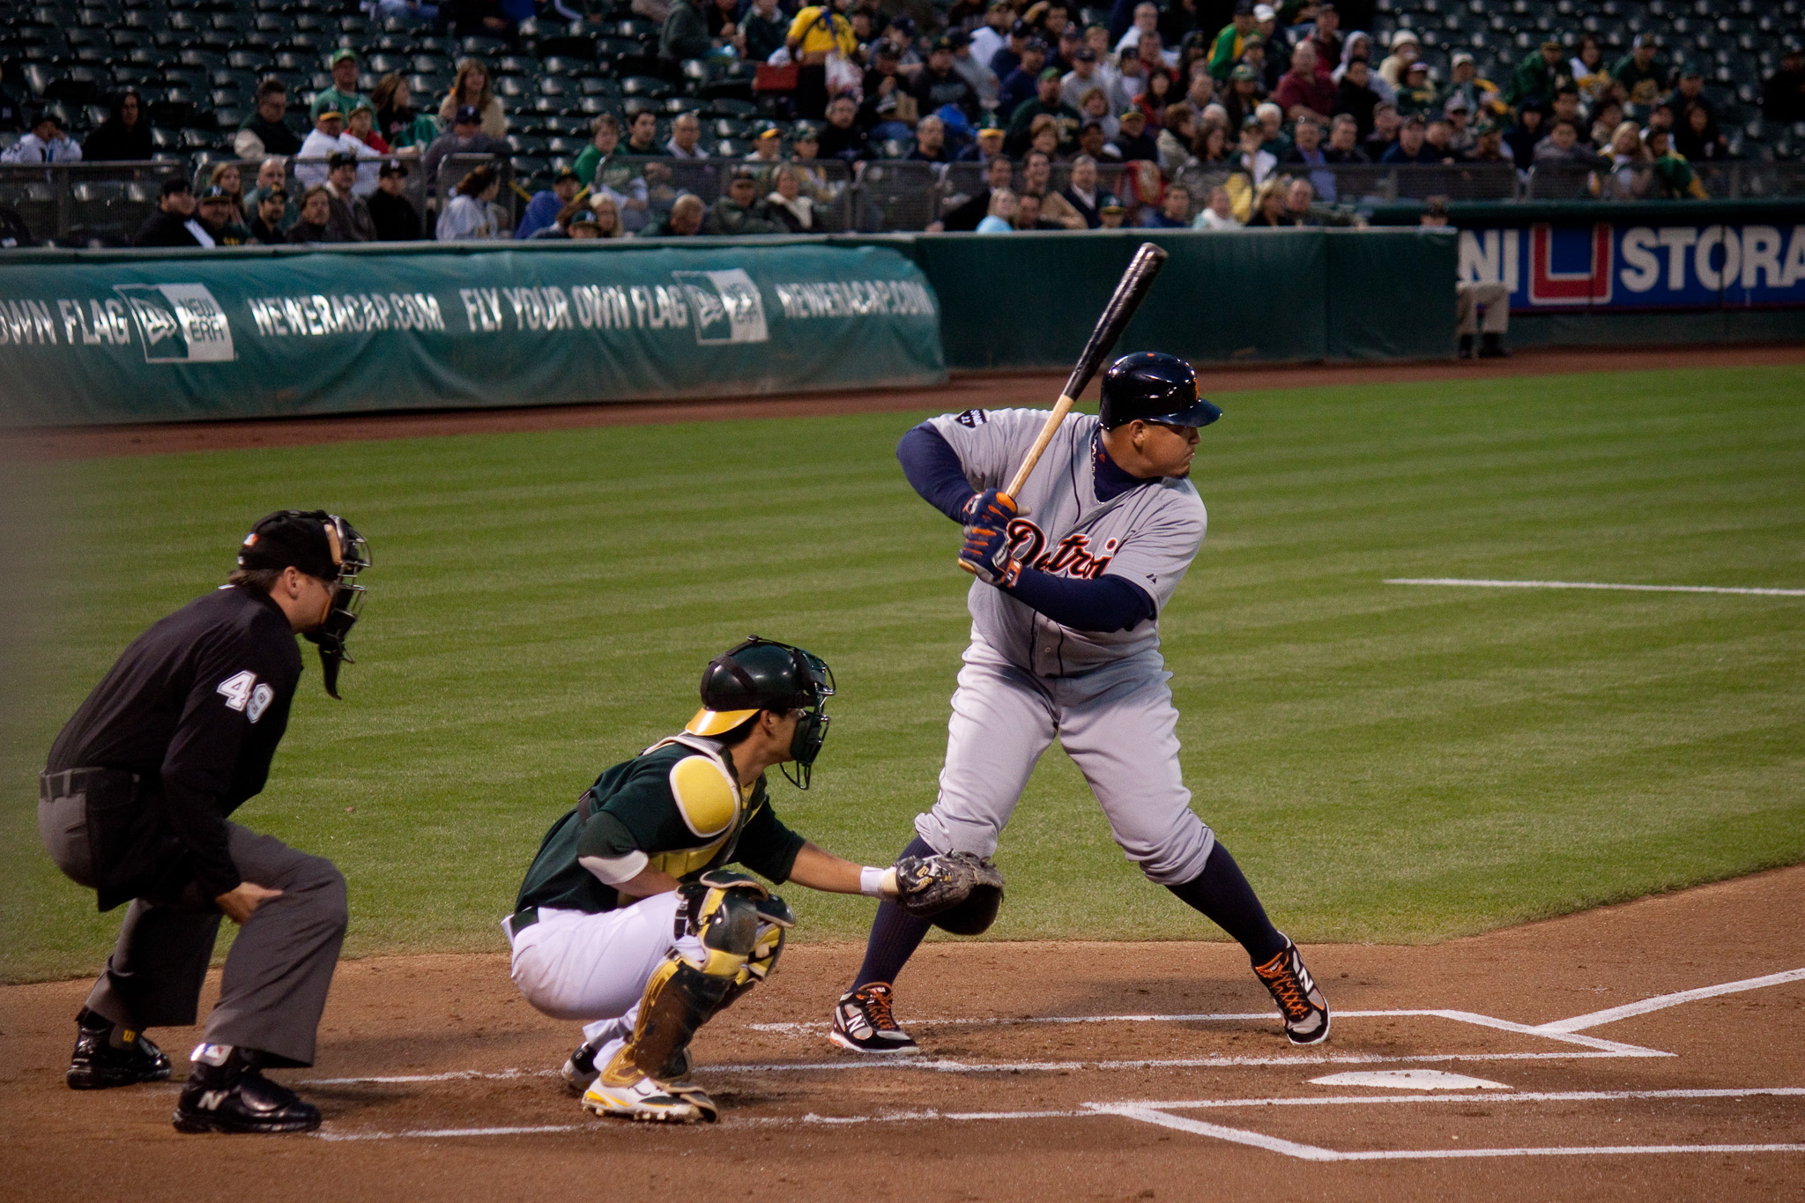
Page # 7
PHASE #2 ….. The Load or Coil
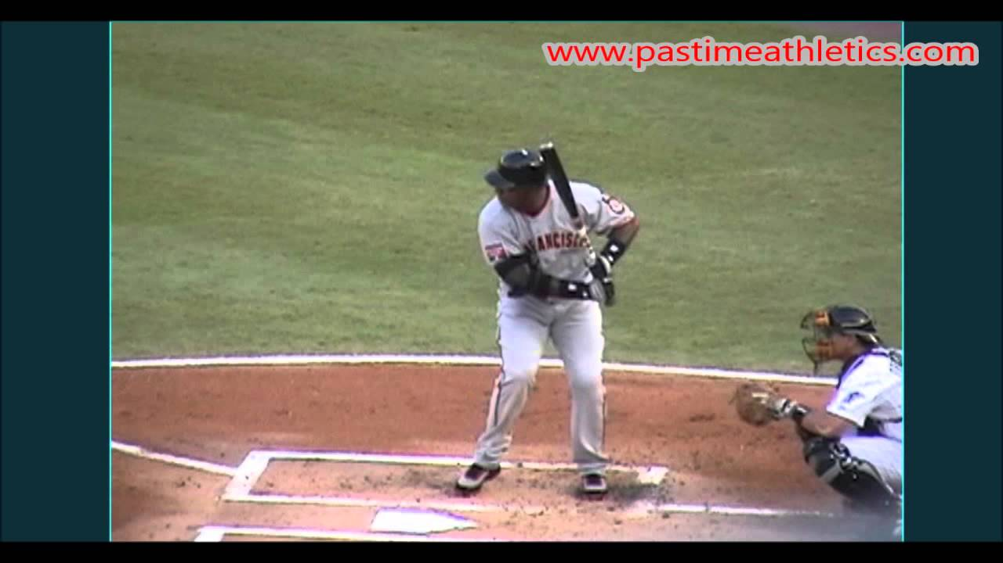

Page # 8

PHASE #2 ..... The Load or Coil

Page # 9
PHASE #2 ….. The Load or Coil

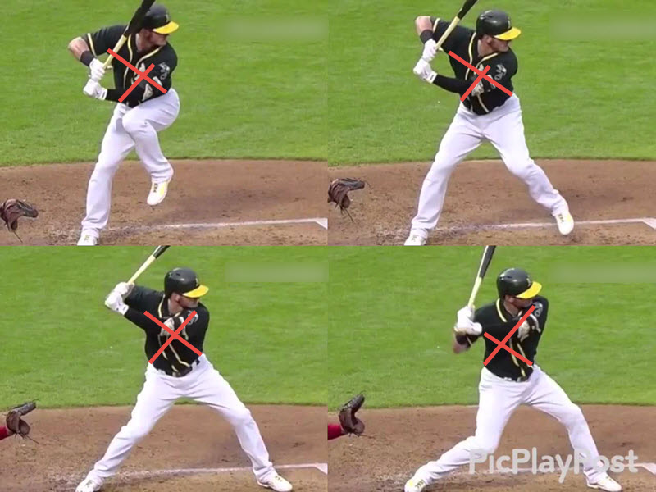

Page #10

