***E. PHASE #5 ….. Launch the Bat to Contact***

**1. Hips turn the bat. Shoulders adjust to the level of the pitch**

**2. Hands stay back and travel in a *curved path* they have not reacted out to the baseball.**

**3. Pull the bat with the bottom hand in a curved path.**

**a. Head stays down to keep front shoulder in and keeps you from**

**pulling off the ball.**

**4. Barrel starts above the hands and inside the baseball.**

**5. Approach the ball and snap the bat.**

**a. Six back side joints stay together to stay stronger through the ball.**

**1.) backside ankle**

**2.) backside knee**

**3.) backside hip**

**4.) backside wrist**

**5.) backside elbow**

**6.) backside shoulder**

**b. Pressure Points and Power Collectors are active for power and consistency.**

**1.) Lead part of the bottom wrist and bottom hand two fingers**

**2.) The Y of the top hand and the top hand index finger**

**3.) The back forearm and the back elbow**

**4.) The lead arm and the front side torso**

**6. Knocking knuckles of top hand take a picture of the pitch.**

**7. We snap the bat to the baseball with a 4 deep stroke. Short, quick, and direct. _____**

**a. Weight**

**b. Hands**

**c. Head**

**d. Eyes**

**8. Steady, quiet head, with bill of helmet down for line drives and 3 ball theory. ______**

**9. Firm front side. ______**

**Page # 17**

***E. PHASE #5 ….. Launch the Bat to Contact***

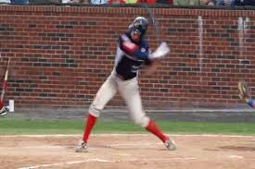

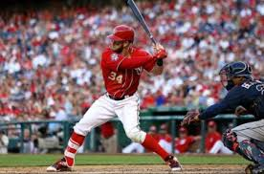

**Page # 18**

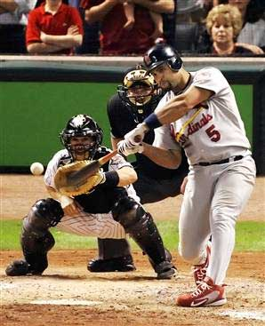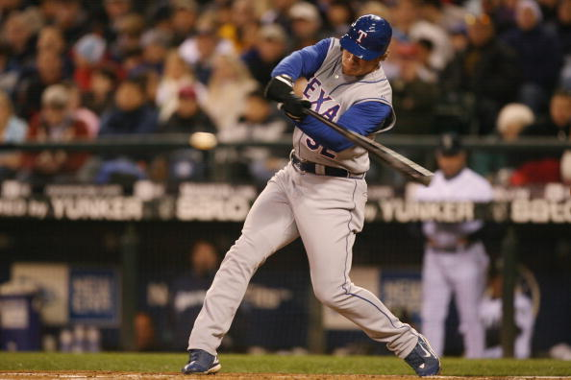***PHASE #5 ….. Launch the Bat***

**Page # 19**

***PHASE #5 ….. Launch the Bat***

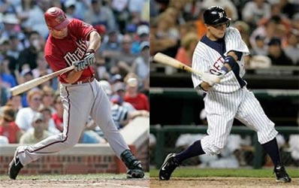

**Page # 20**