G. PHASE #7 ….. Extension #1

1. Extend top hand under the bat. _____

2. The under / under rule is in effect. _____

3. Head and eyes transition from out front tracking the path
of the ball all the way in to contact, to behind the bat as the
bat leads the head and eyes as the baseball is on the way
back out.

4. Hands acts like a hammer taking on a hammer approach.

5. Bat will work itself diagonally up as you go through the ball.

7. No wrist rollover has occurred in the swing.

8. Three ball theory on extension. _____

a. Contact Ball 1
b. Extend and Drive Ball 2
c. Drive Again Ball 3

Page # 25

G. PHASE #7 ….. Extension #1
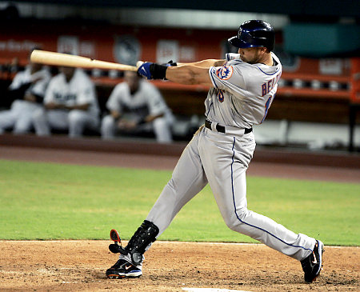
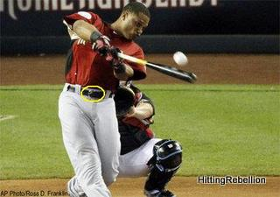

Page # 26

