I. PHASE #9 ….. Finish and Follow Through

1. Bat Arc or Path is Narrow not wide or Loopy… i.e. Flying Out

2. Head will Transfer Slightly back as Momentum and energy forward
is imparted on the ball, absorbing the energy of the ball and directing
it out of the Swing.

3. Hands will Finish around the Top of the Back Shoulder with the
Knob slightly above the Barrel.

4. Barrel will finish around the top of the numbers in a short bat path.

5. Eyes will stay Between the Feet.

a. The eyes will Travel from Contact to 3 -7 degrees out as the ball
flys back out of the hitting Zone.

6. Belly Button, Top of Back Knee, and Back Foot Shoe Strings take
a Picture of the Ball … Where it was hit!

7. Balanced Back Side "L"

Page # 30

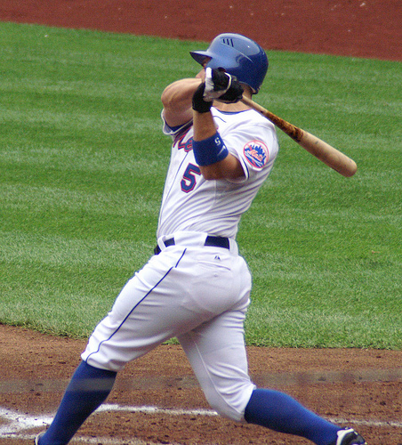
I. PHASE #9 ….. Finish and Follow Through

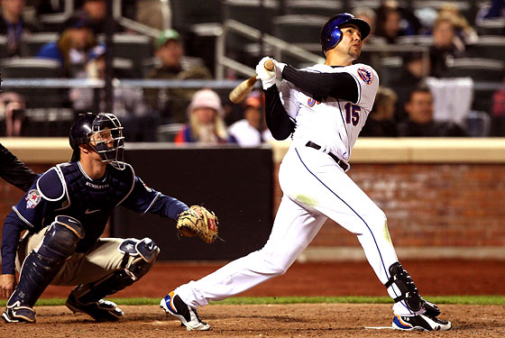

Key Notes: " The swing must have Balance, Flex, and a Strong Front Side from start to finish."

" You make adjustments to your swing using the Brain, Body, and Bat. In that order!"

Page # 31

Contact / Extension / Finish ...... Barrel Plain and Bat Arc
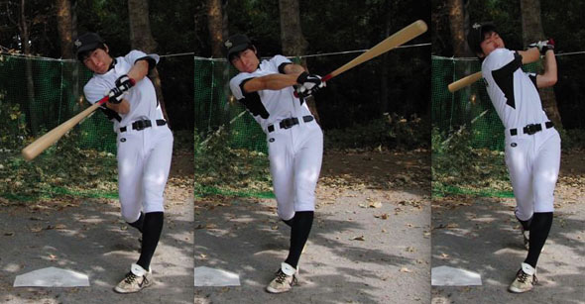

Page # 32

