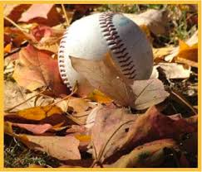
Tri-City Thunder Baseball
Starting September 8th we will be starting our Midget AAA College Prep fall program which will include 12-16 games total and 2/3 practices a week. We start our weight-training program as well the following week. The cost is $250/player, which will include the following:
- 12-16 exhibition games
- BC Minor Fall Tournament (Sept 28-30, in Richmond)
- Practice Jersey
- Flex Fit Hat
- 2/3 practices/week
- Introductory weight training program 1/2 session per week
- Possible selection to the BLE Kamloops tournament
This will take us to the end of October, when we will start our winter training program.
To register or for inquiries please e-mail J.J. Hyde at jhyde@sd43.bc.ca

J.J. Hyde

Head Coach, Tri-City Thunder College Prep Baseball

