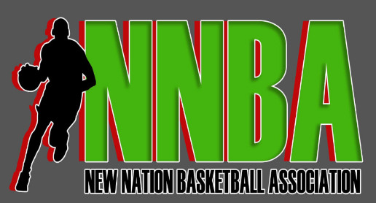
Commissioner: Charles Hickman
Operation Officer: Brandon Bell
Head of Talent Relations: Alondray Rogers
Strategy Officer: Milan Pepper
Brand Officer: Sandy Shipman

League Rules
- Season last from April 2024 – October 2024
  - The league will take a 6-week break from June 16, 2024 – August 1, 2024
    - You are more than willing to play during this period
  - 12-15 Game Season
  - The Robin
  - All Star Game – August 10 in Memphis, TN
    - All Star Game
    - 3 Point Shootout Tag Team (2-Man Team)
    - Ultimate 100s 3-PT Shootout (Single player)
    - Skills Challenge
    - Dunk Contest (If such caliber players exist for this event)
  - Playoffs (Semi-Finals & Championship) in Nashville, TN
- League Fee $300
  - $100 due by April 15 which covers team website and EuroBasket renewal
  - $200 due by August 15 for playoffs
- League Operations
  - 20 Man Roster, 2 Coaches, 1 Owner
  - Players MUST play in 40% of games to be playoff eligible; unless extreme circumstances
  - All teams MUST record all games and post on YouTube
  - All games MUST submit stats 72 hours after game has been played
  - Reschedules & Forfeitures
  - Team Professionalism
  - Player Professionalism
  - Season Awards given on Championship weekend
- All games are played under NBA Rules
  - 3 referees preferred; 2 refs required at any cost
  - 12 Minute stopped clock games
  - 7 timeouts per game
    - All timeouts are 75-secs long (20-sec timeouts were stopped in the 2017-18 NBA season)
    - Except for being entitled to 4 timeouts in the fourth quarter; thus forfeiting unused timeouts
    - Only two timeouts in the final three minutes of regulation; any unused will be forfeited
    - Overtime periods, each team is allowed two timeouts
  - All teams MUST have 24-sec shot clocks. In the event you do not have a regular shot clock. The use of a monitor can be used to reflect a 24-sec shot clock
  - All teams MUST lay down a NBA 3-Point Line

